Subject Code: | CSIT321
Subject Name: | Capstone Project
Submission Type: | Online/Turnitin
Project Title: | Planning and Feasibility Analysis Report
Student/Team Name: | The Hexacore - Avni Pramod, Mohammad Mawiz Ansari,  Syed Sheharyar Ahmed, Mohammed Shehin Kalady,  Nihal Muhamed, Sivajith Ajith Kumar
Student Number: | 8047984, 8335084, 8337354, 8526035, 8276985, 8404744
Student Phone/Mobile No. | +971 54 286 1007, +971 58 597 5201, +971 54 396 0049,  +971 56 636 9656, +971 56 379 6066, +971 55 963 3088
Student E-mail: | ap564@uowmail.edu.au, mma365@uowmail.edu.au, ssa530@uowmail.edu.au, msk965@uowmail.edu.au, nm438@uowmail.edu.au, sak481@uowmail.edu.au
Lecturer Name: | Prof. Farhad Oroumchian
Due Date: | 31/10/2025
Date Submitted: | 31/10/2025

Proposal Cover Sheet
PLAGIARISM:  The penalty for deliberate plagiarism is FAILURE in the subject. Plagiarism is cheating by using the written ideas or submitted work of someone else. UOWD has a strong policy against plagiarism.  The University of Wollongong in Dubai also endorses a policy of non-discriminatory language practice and presentation.  PLEASE NOTE: STUDENTS MUST RETAIN A COPY OF ANY WORK SUBMITTED | DECLARATION:  I/We certify that this is entirely my/our own work, except where I/we have given fully-documented references to the work of others, and that the material contained in this document has not previously been submitted for assessment in any formal course of study. I/we understand the definition and consequences of plagiarism. We/I declare that the project proposal has not been used in any UOWD courses before and that this project idea is a total new idea of the project team  Signature of Student:

Optional Marks:
Comments:

Lecturer Project Proposal Receipt (To be filled in by student and retained by Lecturer upon return of assignment)
Subject: CSIT321 - Project | Project Title: S.H.I.E.L.D
Student / Team Name: The HexaCore | Student Number: 8047984, 8335084, 8337354, 8526035, 8276985, 8404744
Due Date: 31/10/2025 | Date Submitted:
Signature of Student:

Student Project Proposal Receipt (To be filled in and retained by Student upon submission of assignment)
Subject: CSIT321 - Project | Project Title: S.H.I.E.L.D
Student/Team Name: The HexaCore | Student Number: 8047984, 8335084, 8337354, 8526035, 8276985, 8404744
Due Date: | Date Submitted:
Signature of Lecturer:

Table of Contents
Background 3
Project Description and Objectives 4
Overview 4
Main Problems and How we address them 4
Project Scope 5
Competitor Solutions and their limitations 5
Target Niche 6
Pre-Requisites 6
Limitations 6
How we do it 7
High Level System Architecture 7
The High-Level System Operation 8
Software and Hardware Requirements 10
Software Requirements 10
Hardware Requirements 10
Challenges 11
Future Improvements 12
Timeline 13
Project Management tools to be used 13
Team Work Distribution 14
References 14

Background
The healthcare sector in the United Arab Emirates (UAE) has been rapidly transforming under the country’s digital health vision, aiming to establish a world-class, technology-driven medical ecosystem. The UAE National Strategy for Artificial Intelligence 2031 and the Telehealth Guidelines promote large-scale integration of AI, data analytics, and telemedicine to ensure accessible, preventive, and efficient healthcare for all citizens.
Large-scale integration of AI, data analytics, and telemedicine is encouraged by the UAE National Strategy for Artificial Intelligence 2031 and the Telehealth Guidelines in order to guarantee effective, preventive, and easily accessible healthcare for all residents.
The World Health Organization (2023) states that telemedicine has been acknowledged as a "transformative pillar" in international healthcare systems, filling in the gaps in chronic disease management, diagnosis, and follow-up.
Since 2020, the use of telemedicine in the UAE has grown by more than 250%. (UAE Digital Health Report, 2024). Virtual consultation systems have been built by government-led programs including "Doctor for Every Citizen" (DHA) and "Telehealth UAE" (EHS), which provide daily services to thousands of people. However, with limited integration of AI-based analysis, predictive risk modelling, and data privacy frameworks, the majority of current systems concentrate mostly on doctor-patient interaction. This opens opportunities to build smart, patient-focused telemedicine systems that can provide individualized advice, analyse health data in real-time, and protect data in accordance with the UAE Personal Data Protection Law (Federal Decree-Law No. 45 of 2021).
S.H.I.E.L.D (Secure Health Intelligence & Evaluation Logic Database) is proposed as a next-generation telemedicine and remote health monitoring system initially focused on cardiovascular wellness, but architected for future multi-domain scalability.

Project Description and Objectives
Overview
S.H.I.E.L.D (Secure Health Inteligence & Evaluation Logic Database) is an AI-powered mobile telemedicine platform designed to provide real-time cardiovascular health monitoring, predictive alerts, and data privacy for patients and healthcare professionals.
It acts as a virtual health assistant, capable of analysing vital data from wearables or uploaded reports, predicting potential cardiac risks, and offering medically guided recommendations.
Main Problems and How we address them
The modern healthcare system faces several challenges, especially in accessibility, accuracy, and patient data security. Many people delay hospital visits due to cost, distance, or uncertainty about their symptoms, leading to late diagnosis of serious conditions such as cardiovascular diseases. Existing telemedicine platforms often act only as communication tools between patients and doctors, lacking real-time monitoring, and preventive capabilities. At the same time, overcrowded hospitals handle numerous mild or non-urgent cases that could be managed remotely, while patients continue to struggle with understanding their lab results or medical reports. Our project addresses these issues through a comprehensive AI-driven approach by adhering the following objectives:
- To design and develop an AI-powered mobile application capable of analysing heart health indicators such as heart rate, blood pressure, and ECG signals.
- To create a secure, cloud-based health record system for storing and visualizing users’ health data and medical reports.
- To implement a smart emergency response workflow that connects patients to nearby responders or healthcare providers.
- To provide AI-driven analysis of blood reports and health parameters for early risk detection.
- To ensure data protection and patient privacy using AES encryption and Firebase authentication.
- To build a modular architecture capable of integrating additional disease domains in future versions (e.g., diabetes, respiratory, neurological).
The system extends beyond basic consultation apps by incorporating emergency response, AI explainability, and federated learning for privacy-preserving intelligence.

Project Scope
Purpose
The purpose of S.H.I.E.L.D is to provide an intelligent health monitoring system using real-time data that build up to patient safety and accessibility to emergency care using AI and secure data management. The application’s primary domain is cardiovascular health focusing on heart patients and people at risk of heart disease, but it can later be expanded to general health monitoring as the modular system design can integrate more medical domains down the line.
The system acts as a virtual assistant for healthcare that enables users to continuously track their heart health and get AI-generated insights based on their data, securely store and access health records, and get help during emergencies through location-based alerts promptly.

The academic scope of includes:
- AI-based health analysis
- Emergency triage workflow
- Telemedicine integration
- Secure record management
- Data privacy and Cybersecurity
- AL learning and feedback
- System design and interface
Competitor Solutions and their Limitation
The Digital health landscape of UAE has several telemedicine and health-monitoring applications. Applications like Okadoc or MOHAP mainly provide teleconsultation or appointment booking. But these solutions have specific gaps that S.H.I.E.L.D aims to fill
Local Competitors
- Okadoc – Online Appointment Booking Application
While it provides integrated access to multiple hospitals and medical professionals in UAE, it lacks A-based medical or predictive monitoring and is primarily reactive.

- MOHAP Smart App – Provides government health services, medical scheduling and digital health records
A trusted administrative health app with verified medical records but lacks AI diagnosis, report analysis and automated data monitoring.
Global Competitors
- Fitbit/Apple Health Ecosystems
Tracks vitals and medical activities of the user using wearable sensors, but lacks any medical interpretation of the data.

Target Niche
This app can help different types of users:
- Cardiac patients, individuals with high-risk and post-surgery recovery.
- Elderly people who need regular monitoring.
- Health-conscious users who want to track their overall well-being.
- Emergency responders and Paramedics who can get real-time alerts when something happens.
- General users seeking report explanations and insights.

Pre-Requisites
User Pre-Requisites
- Smartphone with OS recommended Android12/iOS 15 or later with 4GB RAM or higher and Camera with min. 8MP.
- Secure and stable Wi-Fi/Mobile Data connection
- Smartwatch/Fitness Band (For Cardiovascular Monitoring)

Technical Pre-Requisites
- Programming skills in frontend and backend frameworks.
- AL/ML understanding for data preprocessing and model training.
- API Integration & Database Management.
Operational Pre-Requisites
- Dataset and Research Access
- Development tools
- Testing environments.
Limitations
- The datasets required for training AI models maybe public or synthetic datasets due to medical confidentiality, which may lead to sourcing data outside UAE demographics.
- The project duration of 24 weeks is not enough for a large scale-data sourcing, training and full deployment of the application, due to which the primary domain of the system is narrowed down to cardiovascular module.
- Legal and ethical concerns exists where the application must comply within UAE federal laws on user data protection.

How we do it

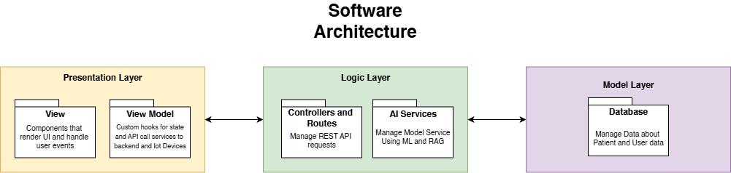

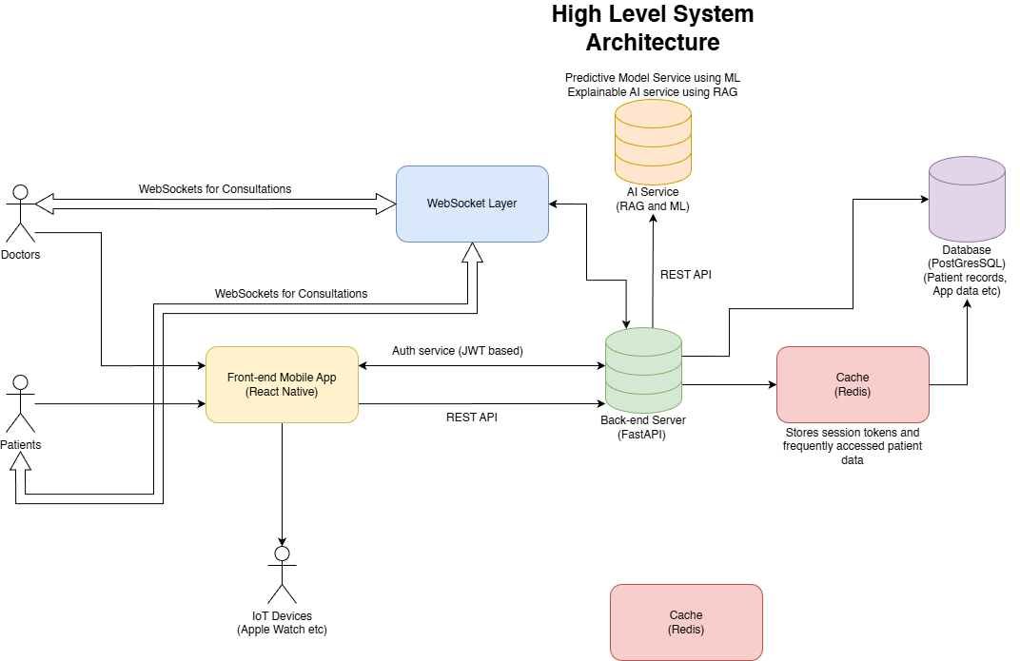
High Level System Operation
The SHIELD system enables patients to securely manage their health data, receive AI-powered insights, and conduct virtual consultations with doctors for clarification or guidance. It also facilitates emergency monitoring and alerts, ensuring timely intervention by first responders and volunteers. The high-level operation describes the interactions among patients, doctors, the frontend, backend, AI models, database, and cache.

- Patient Interaction
- Patients interact with SHIELD through the mobile frontend app.
- Patient requests include actions such as:
- Logging in and managing authentication sessions
- Viewing personal health and fitness data, biometric trends, and historical reports
- Accessing AI-generated health insights and recommendations
- Initiating consultations with doctors via on-demand or scheduled calls
- The frontend manages session tokens, handles UI updates, and forwards requests to the backend through secure API calls.
- Doctor Interaction
- Doctors access SHIELD via the mobile frontend app.
- They can:
- View recent and historical health data of patients they are assigned to or have consulted with.
- Monitor real-time biometric alerts from patients
- Provide guidance, updates, and consultation notes to patients
- Track AI-generated recommendations and assist in interpreting them
- Requests from doctors follow the same flow through the frontend to the backend for processing.
- Front-end Processing
- The frontend handles:
- Capturing input from patients and doctors
- Forwarding requests to the backend via API calls
- Displaying responses, AI insights, and emergency alerts
- Managing authentication sessions using JWT tokens
- Authentication
- SHIELD uses JWT-based authentication to secure sessions and ensure role-based access.
- Both patient and doctor requests are validated by the back-end authentication service, which verifies credentials and manages session tokens.
- Back-end Processing
- The backend receives requests from the frontend and orchestrates all operations:
- Executes business logic and validation
- Queries the database for persistent data or retrieves cached data from the cache
- Communicates with the AI model for predictions, insights, and emergency monitoring
- Sends processed results back to the frontend for display
- AI Model Interaction
- The backend sends relevant patient data, reports, and biometric metrics to the AI model, which leverages a RAG based architecture combined with ML algorithms for analysis.
- Capabilities of the AI model include:
- Generating health insights and recommendations by combining patient data with retrieved knowledge from external and internal sources (RAG)
- Continuously monitoring patient biometrics using ML models to detect anomalies or emergencies
- Triggering emergency alerts to the backend, which are then forwarded to the frontend for notification of nearby first responders and volunteers
- AI predictions and insights may be logged for auditing, analytics, and continuous model improvement
- Database and Cache
- Database: Stores patient and doctor data, consultation history, health metrics, and AI insights.
- Cache: Stores frequently accessed or recently retrieved data to improve performance.
- The backend determines whether to fetch data from cache or database based on efficiency requirements.
- Response Flow
- The backend returns processed responses to the frontend, which updates the UI for patients and doctors.
- Frontend displays:
- Health data and biometric trends
- AI-generated insights
- Consultation notes
- Emergency alerts

Software and Hardware Requirements
Software Requirements
Platforms
- Android
- Android Version: 13.0 (API Level 33) or latest
- Internet Access
- Bluetooth Access: Needed for connecting IoT or wearable health devices (e.g., smartwatch, ECG monitor)
- Location Access: Used during emergencies to share user’s current location with responders
- Notification Access: Required for health alerts and emergency notifications
- iOS
- iOS Version: 15.1 or latest (build with iOS 18 SDK)
- Internet Access
- Bluetooth Access: For pairing with Apple Watch or supported IoT devices via HealthKit
- Location Access: To provide location-based emergency assistance
- Notification Access: To alert users of health abnormalities or urgent situations
Hardware Requirements
Minimum Requirement
Android:
- Minimum Storage: 150–200 MB (for app, AI model, and cached health data)
- RAM: Minimum 3 GB (Recommended: 4 GB or higher for smooth performance)
- Processor: ARM-based processor (Snapdragon 660 or higher)
- Connectivity:
- Bluetooth (for wearable and IoT device integration)
- Internet (Wi-Fi or mobile data for cloud and AI services)
iOS:
- Minimum Storage: Around 180 MB (includes AI model and iOS dependencies)
- RAM: Minimum 3 GB (Recommended: 4 GB or higher)
- Processor: Apple A11 Bionic or newer
- Connectivity:
- Bluetooth (for Apple Watch or HealthKit device connectivity)
- Internet (Wi-Fi or mobile data for cloud sync and alerts)
We will need iot devices like apple watch, fitbit, samsung watch, maybe iot bp machines, and other stuff that we can data from using api, this is all for the benefit of the patient so not necessary. Even normal health machines are fine as long as we have a feature for user to add the data manually.
IoT and Health Devices Integration
Devices Supported:
- Apple Watch: Integration through HealthKit and WatchKit APIs for heart rate, ECG, and activity tracking.
- Fitbit Devices: Data synchronization via the Fitbit Web API for steps, heart rate, and sleep data.
- Samsung Watches: Integration using the Samsung Health SDK for continuous heart and activity monitoring.
- Other IoT Devices: Optional support for Bluetooth-enabled health devices such as blood pressure monitors, pulse oximeters, and ECG machines (using open APIs).
Manual Data Entry
- For users without wearables or compatible IoT devices, the app will include an interface to manually input vital signs (e.g., heart rate, blood pressure, oxygen level).
- The final inclusion of this feature will be confirmed with Prof. Farhad, as noted in the project documentation.

Challenges
- Data Quality & Availability
- Privacy regulations restrict access to trustworthy and annotated medical datasets (ECG, heart rate, and SpO₂).
- Noise, motion errors, or missing samples are common in real-world wearable data, which may result in incorrect classification or false alarms.
- Collecting large labelled datasets for AI model training remains difficult without any clinical partners.

- Negative and False Positive Results
- Real-time emergency detection using sensor data may result in false negatives (missing actual emergencies) or false positives (setting off pointless alarms).

- Emergency Services Integration
- Formal agreements and compliance to local health data regulations are required when connecting the system directly to hospitals or ambulance networks.
- Integration is made more difficult by differences between public and private emergency services, particularly in the United Arab Emirates.

- Security and Privacy
- End-to-end encryption, safe storage, and user consent management are necessary for handling sensitive health data.
- If security layers are not updated often, there is a risk of data breaches or misuse.

- Clinical and Regulatory Validation
- Any AI-powered health monitoring system that makes decisions needs to be approved as a medical device.
- Obtaining such certifications requires clinical trials, documentation.

- Real-Time processing & Scalability
- Scalable backend servers and fast processors are necessary for the continuous monitoring of thousands of users.
- Data loss or delayed alert transmission might result from network problems or poor connection.
- Trust and User Adoption
- People could be cautious to give critical choices to an AI-based system.
- Acceptance depends on ensuring precision, transparency, and an interface that is simple to use.

- Dependence on Hardware
- The accuracy and compatibility of medical sensors or smartwatches have a significant impact on performance.
- Inconsistent readings could result from variations in devices (Apple Watch, Samsung, Fitbit, etc).

Future Improvements
- Predictive analytics and advanced AI
- Create predictive warnings that use trend analysis and long-term monitoring to predict possible cardiac events before they happen.
- Switch to deep learning models from rule-based detection.

- Health Monitoring in Multiple Modes
- For a more comprehensive analysis, include other biomedical signals like blood pressure, respiration rate, glucose levels, and stress metrics.
- For individualized risk rating, combine sensor data with lifestyle and medical history information.

- Hybrid Cloud-Edge Intelligence
- To cut down on delay and protect privacy, move some of the AI computation to the wearable or smartphone so that it can send alert immediately if any issues without waiting for the cloud/internet.
- Heavy analytics and population-level model enhancement are still done in the cloud.

- Network of Community Responders
- Install systems for verified volunteer responders (such as local CPR-certified users) to help in an emergency before an ambulance arrives.
- For the quickest response time, combine routing and mapping techniques.

- Continuous Learning System
- To enable models to learn from user data without transferring raw data to the cloud, implement federated learning.
- To improve accuracy over time, permit retraining on frequently using confidential routines.

- Clinical trials and regulatory certification.
- Collaborate with medical facilities to carry out pilot studies.
- To facilitate clinical implementation, start the formal certification process under medical device guidelines.

- Localization & Accessibility
- Add multilanguage support (Arabic, English, Hindi, Urdu) for the UAE region.
- Improve voice interaction and elderly-friendly UI design.

Timeline
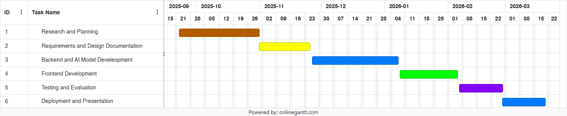

Project Management Tools to be used
- Trello – Team coordination and project tracking
- GitHub – Version control for codebase
- Google Docs and Google Drive – Document collaboration
- Google Meet – Weekly team meetings

Team Work Distribution
Student Name | Student ID | Task
Avni Pramod | 8047984 | Background, Project Description & Objectives
Mohammad Mawiz Ansari | 8335084 | How we do it – High Level System Architecture, High Level System Operation
Syed Sheharyar Ahmed | 8337354 | Software and Hardware Requirements
Mohammed Shehin Kalady | 8526035 | Challenges, Future Improvements
Nihal Muhamed | 8276985 | Timeline, Project Management tools used, Team Work Distribution
Sivajith Ajith Kumar | 8404744 | Project Scope

References
- UAE Government 2023, UAE Strategy for Artificial Intelligence - The Official Portal of the UAE Government, u.ae. Available at: https://u.ae/en/about-the-uae/strategies-initiatives-and-awards/strategies-plans-and-visions/government-services-and-digital-transformation/uae-strategy-for-artificial-intelligence
- Ministry of Health and Prevention - UAE. (2024). Ministry of Health and Prevention releases 2024 achievements report. [online] Available at: https://mohap.gov.ae/en/w/ministry-of-health-and-prevention-releases-2024-achievements-report.
- uaelegislation.gov.ae. (n.d.). United Arab Emirates Legislations | Federal Decree by Law Concerning the Protection of Personal Data. [online] Available at: https://uaelegislation.gov.ae/en/legislations/1972.
- 1. Kim, I., Lee, J. and Kim, S., 2014. Challenges in wearable personal health monitoring systems. Sensors, 14(12), pp.12345–12367.Available at: https://www.ncbi.nlm.nih.gov/pmc/articles/PMC5502108/ [Accessed 28 Oct. 2025].
- Zhang, B., Chen, L. and Li, J., 2025. A survey on security and privacy issues in wearable health technology. Computers & Security, 139, p.103807.Available at: https://www.sciencedirect.com/science/article/pii/S0167404825001427 [Accessed 28 Oct. 2025].
- Al-Jumaily, A. and Olivo, A., 2017. A survey of wearable devices and challenges. ResearchGate.Availableat: https://www.researchgate.net/publication/318717275_A_Survey_of_Wearable_Devices_and_Challenges [Accessed 28 Oct. 2025].
- Elfouly, T., Salim, A. and Hussein, A., 2025. A comprehensive survey on wearable computing for mental and physical health monitoring. Electronics, 14(17), p.3443.
Available at: https://www.mdpi.com/2079-9292/14/17/3443 [Accessed 28 Oct. 2025].
- Khan, M., Farooq, U. and Ahmad, A., 2025. Edge AI for early detection of chronic diseases and the spread of infectious diseases. Future Internet, 15(11), p.370.
Available at: https://www.mdpi.com/1999-5903/15/11/370 [Accessed 28 Oct. 2025].
- Silva, C., Pereira, D. and Gonçalves, R., 2024. Machine learning applied to edge computing and wearable devices for healthcare: Systematic mapping of the literature. Sensors, 24(15), p.78846.Available at: https://www.ncbi.nlm.nih.gov/pmc/articles/PMC11478846/ [Accessed 28 Oct. 2025].
- 8. Arora, N. and Jain, R., 2023. Federated learning for privacy preservation in smart healthcare systems: A comprehensive survey. Available at: https://arxiv.org/abs/2203.09702 [Accessed 28 Oct. 2025].

‌

